HONG KONG INSTITUTE OF VOCATIONAL EDUCATION
Laboratory 9c: Python Web Framework

TASK:
- You are going to implement a system to facilitate teacher to distribute marks to students. First of all, a login menu would be displayed when user access http://localhost:5000
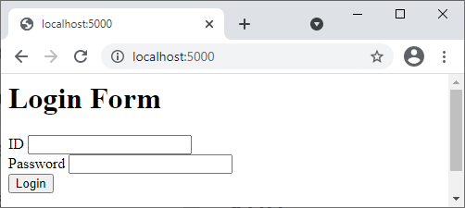

- The first user in this system is administrator with ID admin and password admin. Following is the user interface after user admin logged in.
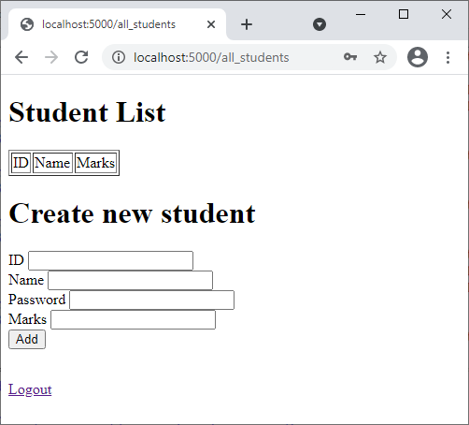

- The administrator may create a student account by entering the corresponding student id, name, password and marks. The user added should be displayed in the student list after the administrator pressing the “Add” button
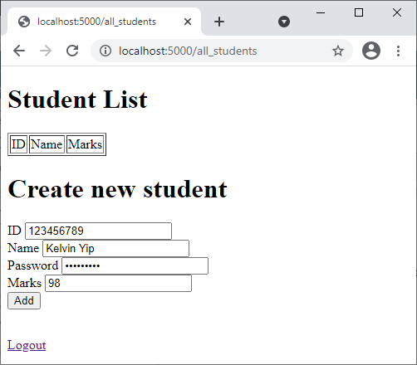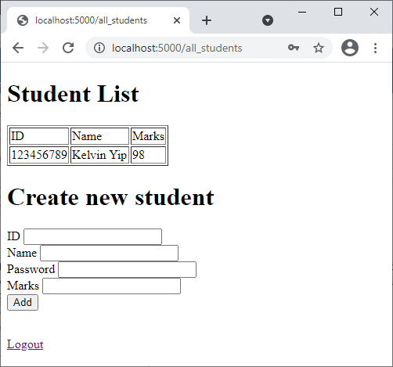

- Logout the administrator. Login with the student you just created. The student’s information should be displayed.
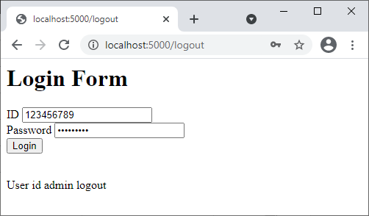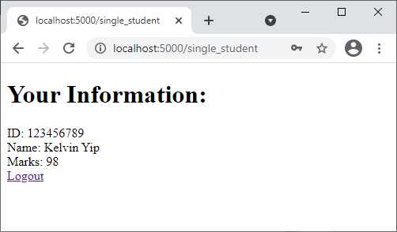

- Please note that user should not be able to access the /all_students page or /single_student page directly without login.
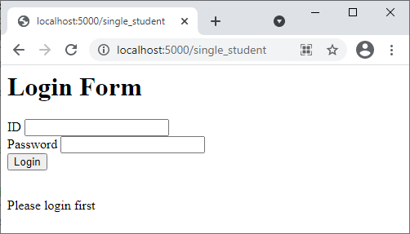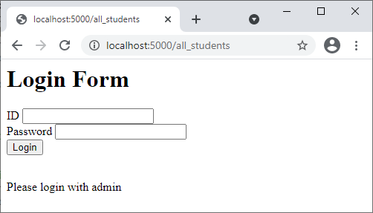

- Name your files using the following hierarchy.
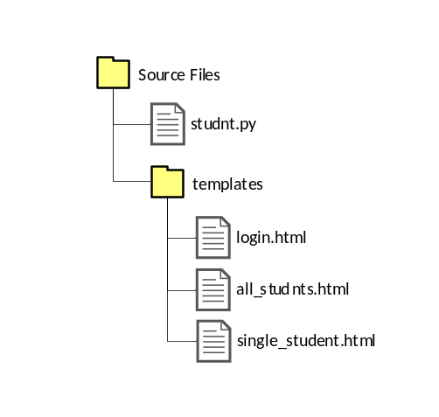

Complete your answers of the following files below:

Answers: student.py

Answers: login.html

Answers: all_students.html

Answers: single_student.html

